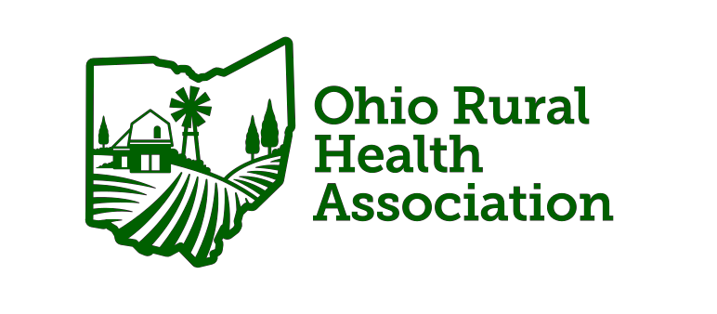

STRATEGIC PLAN
2025-2028

November, 2024

Introduction
This document provides an overview of the Ohio Rural Health Association’s 2024-2027 strategic plan. The plan includes guiding principles, four strategic priorities and a set of associated outcomes, performance measures and strategies for implementation. This three-year plan serves as a roadmap to guide us towards achievement of our vision and what we believe is important to us as an organization to guide us in addressing the health needs of rural Ohioans.
Mission:
Lead in promoting the health and well-being of the state's rural citizens and communities through dedicated advocacy, effective communication, and comprehensive education.

Strategic Priorities
The Association’s strategic priorities are listed below.
Strategic Priority 1: Awareness/Advocacy
Strategic Priority 2: Education
Strategic Priority 3: Engagement
Strategic Priority 4: Alignment

Development Team
Development of this plan was led by the ORHA “Team” (Executive Board of Director team, the Board of Directors and the Association’s Executive Director). The Team took in account information shared by the members of the Association, its committees and the Board itself.
Executive Board:
- Beth Kluding, Board President
- Allen Hocker, Immediate Past Board President
- Brei Miller, Board Secretary
- Christina Barnes, Board Treasurer

Additional Board of Directors:
- Marianella Napolitano
- Amy Rettig
- Laura Akgerman
- Ken Martin
- Brent Burkey
- Sharon Casapulla
- Cory Cronin
- Belinda Leslie
- Emily Eddy
Executive Director
- Rosanna Scott

Our Process
ORHA worked to guide strategic planning efforts by examining work-to-date and what work is most needed to foster growth for the organization in the coming years.
The planning process calendar is as follows:
July, ’24 First Executive Team Meeting
August, ’24 Second Executive Team Session
September, ’24 Full Board of Director Session
November, ’24 Approval of Board of Directors
December, ’24 Plan communicated to Membership

July, ’24 Meeting
Leadership Team met, discussed priorities and conducted a SWOT analysis of the organization.

August, ’24 Meeting
Leadership Team met and discussed the priorities, goals and next steps

September, ’24 Meeting
Leadership Team reviewed the plan with the full Board of Directors in an effort to obtain input.

November, ’24 Meeting
Board of Directors voted TBD

December, TBD ‘24
Strategic Plan communicated to membership and placed on organization’s website.

PRIORITY #1: Awareness/Advocacy

GOAL | YEAR(s) | PLAN | OUTCOME
Develop Relationship with state legislative leaders | 1,2,3 | State Advocacy Day | 1 Advocacy Day Held/Relationships Developed
Highlight ORHA Advocacy Efforts to general Membership | 1,2,3 | Annual Virtual Meeting to educate all members on advocacy. Invite Members to participate in advocacy efforts | Virtual Updates Held Each Year/Active Legislative Committee Meetings Held Quarterly
Develop Relationship with state legislative leaders | 1,2,3 | Meet with Legislators | Year 1: 3 Key Relationships Developed  Year 2: 3 Additional Relationships Developed  Year 3: 3 Additional Relationships Developed
Annual National Rural Health Day Event | 1,2,3 | Provide a Virtual Educational/Celebration Event | Members/General Public Attend/Awareness Created

PRIORITY #2: Education
GOAL | YEAR(s) | PLAN | OUTCOME
Members Receive CE Credit for Webinars | 1,2,3 | Offer specific opportunities for CE Credit | Year 1 and 2: 2 CE Webinars  Year 3: 3 CE Webinars
RHCs receive Educational Opportunities | 1,2,3 | Work with SORH to Offer Specific Education Opportunities | Year 1,2,3  Six Specific Opportunities per year
RHC Advisory Group | 1,2,3 | Hold Quarterly Committee Meetings to determine educational needs for RHCS | Committee Meetings Held with Active Advisory Group
Ohio Rural Health Conference with *RHC/CAH Track | 1,2,3 | Annual Event | Event Held Annual/consistent rotating locations throughout the state with specific educational tracks/CE
General Webinars | 1,2,3 | General Education Opportunities | At Least 8 Provided
Student Education Provided | 1,2,3 | Students Attend Conference *Free of Charge | Over 20 students attend each year
Educational Campaigns, Including, but not limited to topics such as Health Equity, Health Literacy, Tobacco Cessation and Mental Health. | 1,2,3 | Create Campaigns that share information, resources and opportunities for engagement | Online Campaigns that include educational and specific information to empower members to share information within their rural communities
PRIORITY #3: Engagement
GOAL | YEAR(s) | PLAN | OUTCOMES
Update Mission Statement | 1 | Create an updated statement that reflects work | Updated Statement Created
Connect and Engage with Members (Information) | 1,2,3 | Social Media, Newsletters, New Member Platform Year 2 | Stronger Member Connections/Grow Members 10% year 2/3
Rural Health Champion Program | 1,2,3 | Year 1: Program Develop and Implemented  Year 2/3: Program Maintained | Recognize Outside Members for their Work (online and at annual conference)

PRIORITY #4: Alignment (Identify Key Partners for Collaboration)

GOALS | YEAR(s) | PLAN | OUTCOMES
State Office of Rural Health | 1,2,3 | Meet Consistently | Create ongoing opportunities for members through SORH partnership
Strengthen existing partnerships | 1,2,3 | Continue to collaborate with groups such as universities and businesses | Continue to create pathways and opportunities to offer joint education, resources and programming
Identify New Partnerships with Multi-Sector Partners, including, but not limited to, medical professionals , for profits organizations, nonprofits, social service providers, public health departments, universities, and others. | 1,2,3 | Develop new relationships to strengthen rural Ohio | Year 1: 3 New Partnerships  Year 2/3: Additional 3 partnerships per year

Tracking Our Performance
We will monitor the ongoing monitoring and reporting of progress relative to the strategic plan’s goals and outcomes.
Ongoing Monitoring & Reporting
Data associated with the outcomes are updated monthly, quarterly, bi-annually or annually as appropriate depending on the measure and availability of data. These data, as well as strategy implementation, will be shared with the Executive Leadership Team on a quarterly basis to monitor progress towards achievement of outcomes.
Annual Review
An annual review, led by the Executive Director and Executive Team will be conducted. Accomplishments will be highlighted (and shared as appropriate with members) strategies will be revised/added (as needed), and any needed changes to the outcomes will also be considered.
A full strategic planning process is repeated approximately every three years, or when there are significant changes in the internal or external environment that necessitates a significant change in a strategic direction.

